***HOW TO LIVE A HEALTHY LIFE?***



The issue of a healthy lifestyle is very serious but the people take it very lightly. Often, it is seen that the people take steps to improve their lifestyle but due to lack of determination quits in the midway.

Moreover, for a healthy lifestyle is it important that you take small and one-step at a time. Also, do not go over excess with it. Besides, this healthy lifestyle will help you in life in a lot of ways.

**Habits that keep you healthy**

For keeping your body and mind healthy you have to follow certain rules that will help you achieve your goal. Besides, there are certain measures that will help you to stay healthy.

First of all, for being healthy you have to plan and follow a strict diet. This diet should contain all the essential minerals and vitamins required by the body. Also, eat only healthy food and avoid junk and heavily carbohydrate and fatty food.

In addition, wake up early in the morning because first of all, it’s a healthy habit. Secondly, waking up early means you can get ready for your work early, spend some quality time with your family. Besides, this decides time for your sleep and sleep early because it de-stresses body.

Avoid the mobile- the biggest drawback of this generation is that they are obsessed with their mobile phones. Moreover, these phones cause many physical and mental problem for them. So, to avoid the negative effects of mobile the usage volume of them should be reduced.

Connecting with positive minds because the more you indulge with these people then less you will go to the negative side.

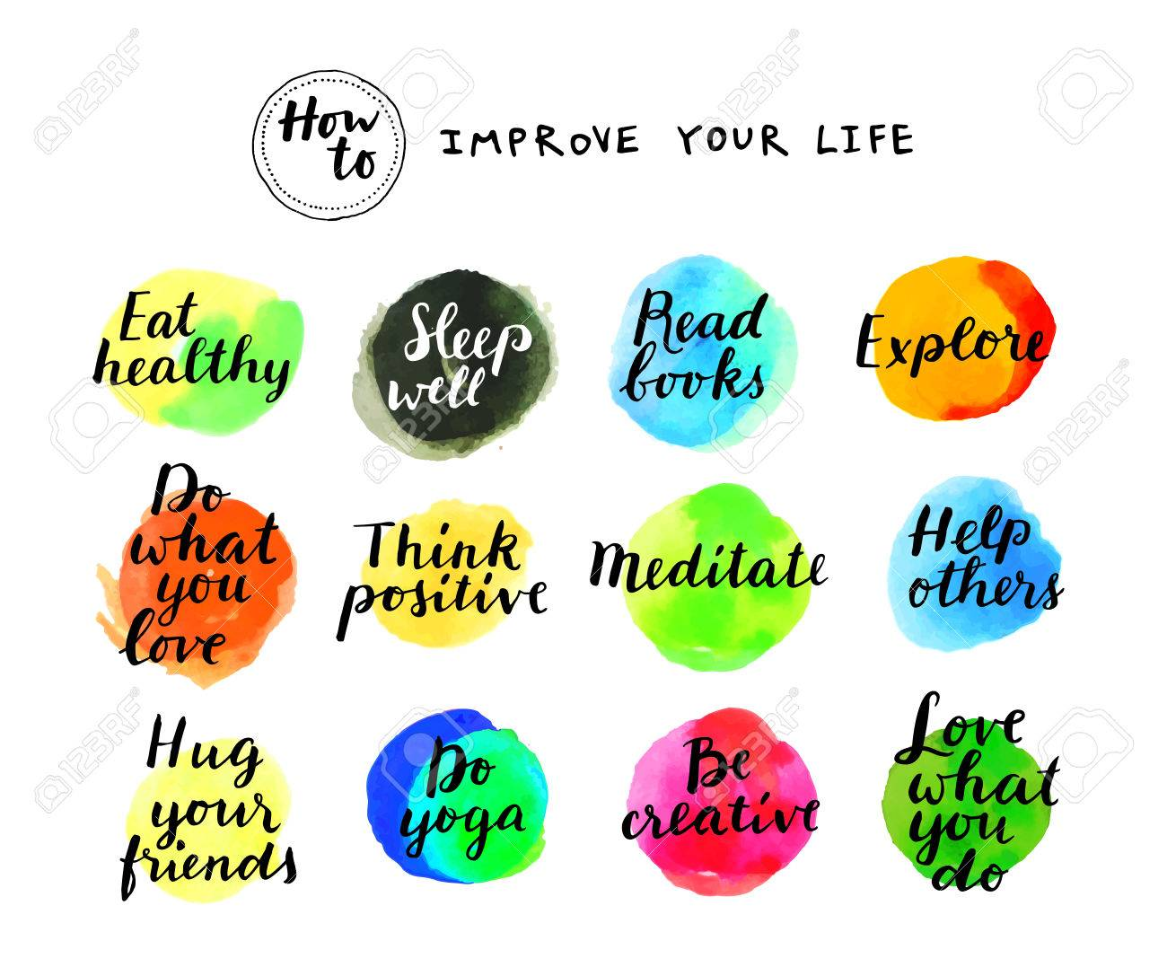

1. **Maintaining healthy relationships:**

Relationships play an important role in mental health. Research shows that not only can healthy and supportive relationships increase your happiness, life satisfaction, and psychological well-being, they can also reduce the risk of suicide. However, not all relationships are created equal. Negative relationship can create toxic situations involving conflict and stress. Disconnecting from unhealthy relationships and fostering healthy ones is vital to your well-being.

1. **Get a good sleep:**

The quality of your sleep directly affects your mental and physical health. It also affects the quality of your life, including your productivity, emotional balance, creativity, and even your weight. A person must take minimum 7 hours sleep daily.

1. **Exercise daily:**

Regular exercise has a profoundly positive impact on your physical and mental health. Not only help in weight loss but it can also curb depression, relieve anxiety, improve your memory, and help you sleep better, all of which boost your overall mood. One must exercise 30 mins every morning.

1. **Find meaning to you work/career:**

The career you choose can form part of your identity and shape how you feel about yourself. Always choose your passion which suites and defines you not by family aur peer pressure, first listen to yourself and decide your career in which you have more interest.

1. **Make leisure time:**

Leisure time is more important than many people realize. Leisure activity lowers your stress, anxiety and improves your mood.

So indulge yourself with a pleasurable activity.

**Things that should be avoided for a healthy lifestyle**

We knew that there are several bad habits that affect our healthy lifestyle. These habits can cause much harm to not only to the body but to the society too.

In addition, these habits are also the cause of many evils of society. The major healthy lifestyle destroying habits are smoking, drinking, junk food, addiction, meal skipping, and overuse of pills.

All these activities severely damage body parts and organs which cannot be replaced easily. Besides, they not only cause physical damage but mental damage too.

**Benefits of healthy lifestyle**

A healthy lifestyle has many benefits not only for the body but for the mind too. Also, if you follow a healthy lifestyle then you can reduce the risk of having cancer, heart disease, diabetes, obesity etc.

To sum it up, we can say that there are various benefits of living a healthy lifestyle. Also, a healthy lifestyle has many benefits to your social as well as personal life. Besides, it improves the relationships in the family. Most importantly, the person who lives a healthy lifestyle lives longer as compared to those who do not.